**Digital marketing**

Assignment -2

**Topic:** 5 brands and their goals and KPI's their use to measure their succes.

1.**Coca-Cola**

**Goals:-**

1.To craft the brands and choice of drinks that people love and enjoy, to refresh them in body and spirit.

2. growing the company, the industry, and crafting brands and drinks that people love.

3.**Refresh the world**

To refresh the world and make a difference.

4.Short term goal**:** To guarantee consumer satisfaction and expanding its services to the underserved segments of the society.

5.Long term goal**:** To focus on expanding the commercial beverage industry in developing countries.

6.The most effective goals are those that are SMART (specific, measurable, attainable , realistic, and time-bound.

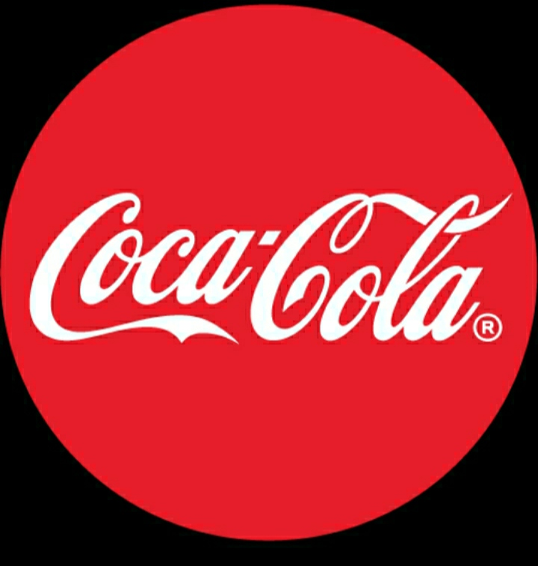

**KPI's:-**

The Coca-Cola Co., the soft drinks giant, is focusing on weekly consumption levels, brand equity and the profit from its investment as it tracks the impact of its marketing programs**.**

KPIs for Coca-Cola could encompass brand mentions on social media, sales volume, market share, and customer sentiment analysis.

**2.Tesla**

**Goals:-**

1.Create the most compelling car company of the 21st century while driving the world's transition to electric vehicles.”

2.to accelerate the world's transition to sustainable ener.

3.short term goal:improving revenue generation, profitability, and cash.

4.long term goal:becoming the world's biggest car maker by volume.

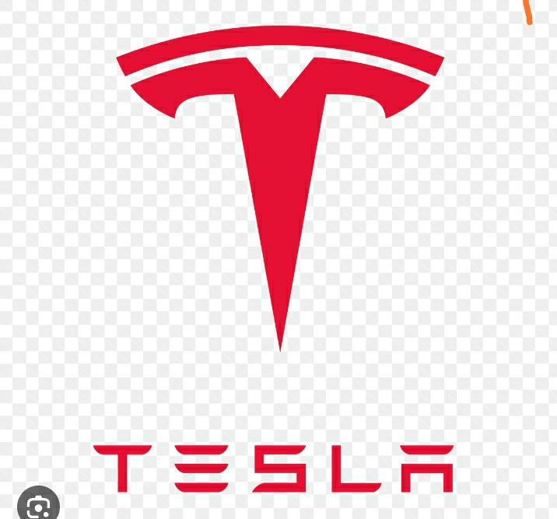

**KPI's:-**

customer satisfaction, internal process quality, employee satisfaction and financial performance.

**3.Amazon**

**Goals:-**

1.customer obsession rather than competitor focus, passion for invention, commitment to operational excellence, and long-term thinking.

2."to be Earth's most customer-centric company."

3.to be earth's most customer-centric company; to build a place where people can come to find and discover anything they might want to buy online.”

4.be the world's best employer and safest workplace.

5.providing customers with an easy, personalized, and convenient shopping experience

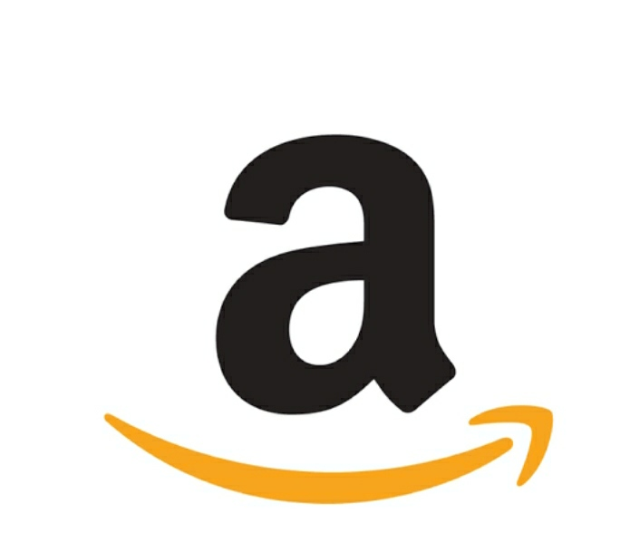

**KPI's**

Amazon KPIs include daily sales, conversion rate, and site traffic. Increase Buy Box Wins consistently and progressively. Amazon KPI has Amazon Feedback rating. customer service metrics, Late Shipment Percentage, and Refund Requests.

**4.Nestle**

**Goals:-**

1.to unlock the power of food to enhance quality of life for everyone, today and for generations to come.

2. "Good Food, Good Life"

3.end all forms of malnutrition,

4.Nestle's main goal is to be the head in Nutrition Condition and Wellness.

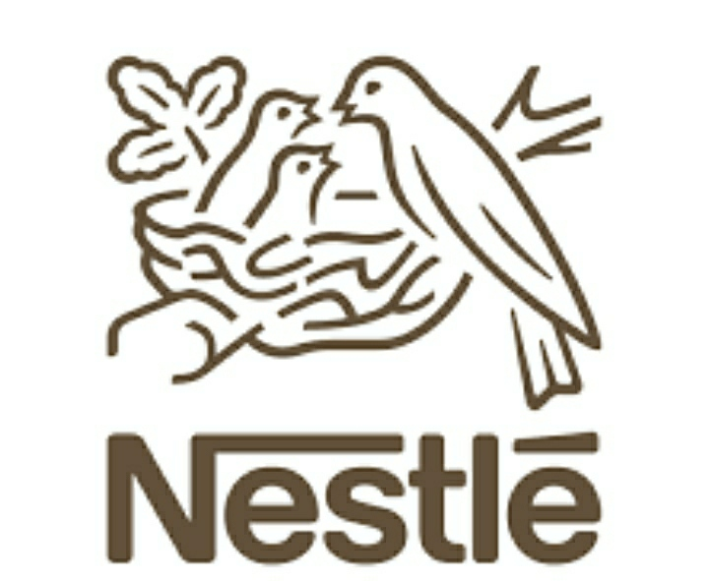

**KPI's:-**

Nestle's key performance indicators (KPIs) provide a focus for measuring and reporting Creating Shared Value, sustainability and compliance.

It uses the marketing,SEO,social media to promote their products.

**5.starbucks**

**Goals:-**

1.To inspire and nurture the human spirit – one person, one cup and one neighborhood at a time

2.to establish Starbucks as the premier purveyor of the finest coffee in the world, while maintaining our uncompromising principles while we grow.”

3.Long term goal:Starbucks set a multi-decade commitment to reduce our carbon, our water and our waste footprints by half by 2030.

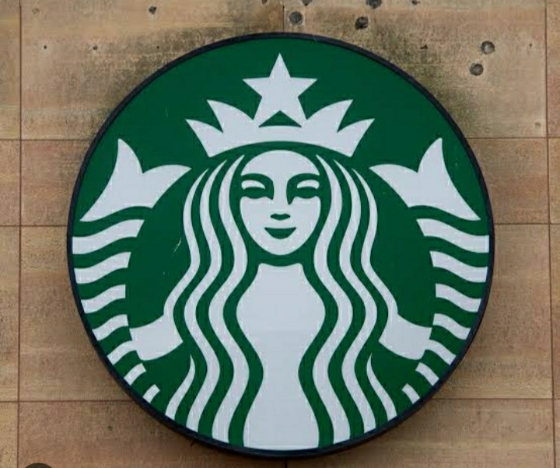

**KPI's**

Average Cost of Goods (ACG) is a key performance Indicator (KPI) for a Starbucks franchise that measures the average cost of raw materials, labor, and other associated costs in producing a product.

It doesn't involve in social media promotions.